
[Project]
made possible in part by
LCRA Community Grants
and
Bluebonnet Electric Cooperative
[Year]

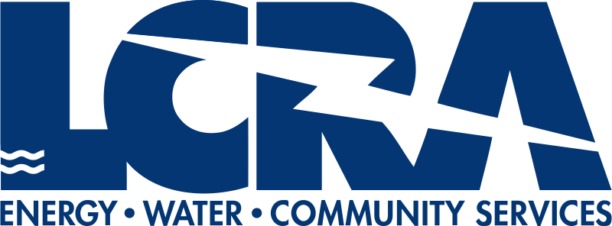 | 

