LCRA WATER QUALITY ADVISORY COMMITTEE MEETING
Tuesday, March 6, 2018
LCRA Redbud Center, 3601 Lake Austin Blvd, Austin, TX

Welcome and Introductions
The Middle Basin meeting of the Clean Rivers Program (CRP) Colorado River Basin Water Quality Advisory Committee (WQAC) was held March 6, 2018 at 10:00 a.m. at the Lower Colorado River Authority (LCRA) Redbud Center, 3601 Lake Austin Blvd., Austin. Lisa Benton, LCRA CRP coordinator, welcomed the 24 attendees, and asked them to introduce themselves and state their affiliations.

Clean Rivers Program Updates for Colorado River Basin – Lisa Benton, LCRA
Benton provided historical background information on the Clean Rivers Program and the roles of the various stakeholders, including the Upper Colorado River Authority (UCRA) and the City of Austin (CoA). She stressed the importance of data collection, quality assurance, and data management, and how the Water Quality Advisory Committee helps guide resources to gather and assess water quality information to identify and address water quality issues throughout the basin.

The Colorado River basin CRP program has received additional funds in the FY18-19 contract cycle, Benton explained. These funds will be used to increase the frequency of monitoring on the Highland Lakes over the next year and a half to improve the accuracy and predictable capabilities of the Colorado River Environmental Models (CREMs). CREMs models evaluate water quality trends and predict the water quality impacts of changes in land use, permitting or regulations in the Highland Lakes watershed. Benton then provided a list of online LCRA water quality resources that included waterquality.lcra.org, cms.lcra.org, crwn.lcra.org, and hydromet.lcra.org.

Sarah Eagle, Texas Commission on Environmental Quality (TCEQ) CRP project manager for the Colorado River basin, provided information on the status of the Texas Integrated Report of Surface Water Quality. The 2018 Integrated Report process is in full-swing with public comment expected to occur before 8/31/2018. The Draft 2016 Integrated Report is still being tied up from finalization by the nutrient standards, but action is expected soon.

Water Quality Hot Topics – Brent Lyles, Colorado River Alliance
Lyles began his talk by briefly highlighting the work that the Colorado River Alliance (CRA) does to champion the long-term vitality of the Texas Colorado River through education and engagement. He stated that the work CRA does boils down to three things: educating Colorado River stakeholders on water science, reducing water waste and river stewardship. With roughly 15% of Texas in the Colorado River basin, there are a lot of opportunities and challenges for water resources. Lyles highlighted the return of otters to the lower river below Austin, an exciting sign that the river is supporting an increasing diversity of wildlife. Lyles then spoke about the recent hot topics in water quality throughout the basin, beginning with the Dripping Springs wastewater discharge permit dispute and discussing the pressures that an increasing population can have on water and wastewater management. He then spoke about invasive non-native zebra mussels and the potential that they have to impact recreation, ecology and infrastructure in the three reservoirs where zebra mussels are currently found and perhaps more reservoirs in the future if the spread continues.

Native freshwater mussels are also another hot topic, Lyles stated. In fall of 2018, four Colorado basin candidate mussel species for listing under the U.S. Endangered Species Act (ESA) will be considered for proposal under ESA and in the fall of 2019 will be considered for a final listing decision under the ESA. These listing decisions have potential implications for the way that water is managed in our basin.

Hydraulic fracking that is taking place in the upper part of the Colorado River basin is an issue that Lyles highlighted as a strain on water resources with potential impacts to water quality. In addition, agriculture can have an impact on water quality and resources, but with a continued shift toward sustainable grazing management and agricultural practices, there are encouraging changes taking place.

Lyles continued by highlighting the extremes of floods and droughts that this basin has routinely seen. With the devastating impacts of Hurricane Harvey fresh on our minds, we know the impacts that floodwaters of this magnitude can have on the communities and ecosystems of the Colorado River. On the opposite side of the spectrum, drought is something we can’t forget, as well. History tells us, Lyles explains, that mega-droughts lasting decades have been documented and that we never know when a drought of that magnitude could occur but we must always be aware and move towards better solutions for a growing population. He said that the City of Austin’s Water Forward process is trying to address that very issue. Water Forward is a holistic and inclusive approach to water resource planning for the City of Austin that embraces an innovative and integrated water management process. The goal of Water Forward is to ensure a diversified, sustainable and resilient water future with strong emphasis on water conservation.

Tyson Broad of Llano Watershed Alliance wanted to emphasize the effect that even minor droughts can have on the recharge of aquifers and base flows in the Hill Country, stating that when average annual precipitation dips below 70%, the recharge in some of these systems approaches zero.

For more information on the Colorado River Alliance, visit coloradoriver.org.

Zebra Mussels: Invasion Status and Monitoring Plan – Stephen Davis, LCRA
Stephen Davis began the presentation by providing background information on the biology of zebra mussels. These non-native invasive species are originally from Eurasia and first entered the United States in 1988. Since then they have spread throughout the country, primarily by recreational boat traffic and downstream dispersal via flow. Texas is currently the most southern location in the zebra mussel’s range. For an updated map on range distribution in Texas visit https://tpwd.texas.gov/huntwild/wild/species/exotic/zebramusselmap.phtml

Davis explained that female zebra mussels can spawn up to 1 million eggs/year. When the eggs are fertilized and become larvae they float in the water column until they become juveniles, at which time they will settle onto a surface and begin growing. The zebra mussels in Texas grow much faster and have a much shorter lifespan than zebra mussels in the northeast U.S. This is due to the warmer waters in Texas that increase the metabolism of the zebra mussels.

Davis then described how to identify these invasive species. Because zebra mussels attach to surfaces, they can easily be distinguished from native mussels, which burrow into the sediment, or the non-native Asian clam (Corbicula sp.). In addition, zebra mussels have a D-shape and are often found with the alternating dark and light stripes that gave them their name.

A chart of the current invasion status in the Colorado River basin was displayed (Table 1). Lake Travis was the first location in the Colorado River basin where zebra mussels were found. They then spread to Lake Austin, which is just downstream of Travis, and later to Lady Bird Lake. Travis and Austin are “infested”, meaning that we have reproducing populations, Davis explained. But Lady Bird Lake is only suspect at this time because no adult zebra mussels have been found, only larvae.

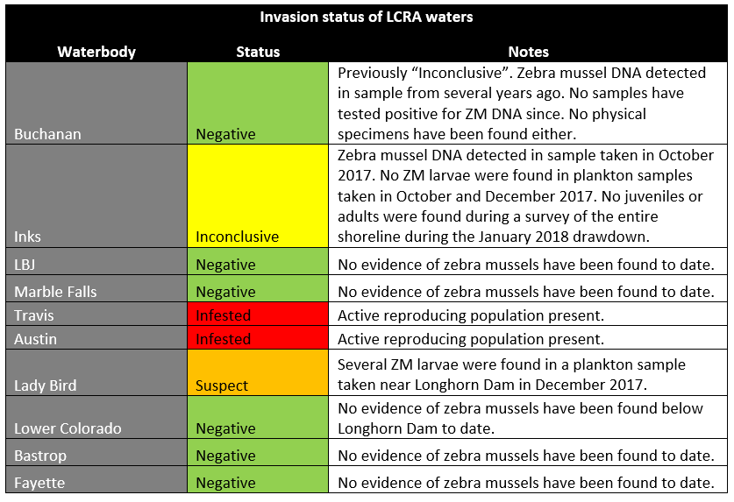
Figure 1. Zebra mussel invasion status of reservoirs in the lower Colorado River basin.
Zebra mussels can have recreational, ecological and economic impacts. Scientists studying zebra mussels in Texas have documented a large “boom” in population when the mussels first invade, followed by a “bust” a few years later when their numbers decrease and they are not as much of an issue. But time will tell and populations will fluctuate throughout time. Davis said it is important to remember the Texas Parks and Wildlife Department’s Clean Drain Dry protocol to help prevent the spread of zebra mussels to other water bodies.

And now that zebra mussels are in these lakes, they are here to stay. There is no feasible means of eradication and the focus needs to be on management, Davis stated.

There are a variety of management strategies that have been tried. These include manual removal, antifouling paints/alloys, chemical feed systems, desiccation, temperature control and flow control.

LCRA has taken many actions to address zebra mussels. A volunteer settlement sampler monitoring program has been in place for over 5 years in the Colorado River basin, an internal decontamination and spread prevention protocol has been developed for all LCRA watercraft, routine inspections of infrastructure are performed, and a thorough review of management techniques are among the actions taken. Davis stated that LCRA is a resource for lakeside property owners or lake users who have questions about zebra mussels. He provided his contact information so that anyone with questions could reach out: Stephen.davis@lcra.org.

A stakeholder asked a question about what you do with zebra mussels if you find one- how do you dispose of them? Davis explained that there are rules about being in possession of invasive species and that it is against the law to transport them or place mussels into the trash, so it is recommended that the mussels are crushed and then pushed back into the lake where they came from.

Inks Lake Freshwater Mussel Survey – Stephen Davis and Lisa Benton, LCRA
After a short break, Benton introduced the next presentation on native freshwater mussels in Inks Lake. Freshwater mussels are an important part of terrestrial and aquatic ecosystems. They are reported to be able to filter up to 8 gallons of water per day, providing a crucial ecosystem service.

Benton explained that these native mussels can be found in all waterways of the Colorado River basin, but only in the past 10 years has a significant amount of effort taken place to learn more about them. This surge of data collection and research came as a result of Texas Parks and Wildlife Department listing 15 freshwater mussels in Texas as state-threatened in 2009, and subsequent announcement that five central Texas mussel species warrant protection under the federal Endangered Species Act (ESA) in 2011 and were listed as candidate species. The first round of these candidate species are due to be evaluated for listing under the ESA starting now, with a proposal decision expected fall 2018 and a final listing decision expected fall 2019.

During a recent 8-feet drawdown on Inks Lake, LCRA took the opportunity to survey the shoreline for freshwater mussels. They invited colleagues from various state and research agencies who were interested in mussels to help, as well. Mussel enthusiasts from Texas Commission on Environmental Quality, Texas Parks and Wildlife Department, City of Austin, U.S. Fish and Wildlife Service and Texas State University assisted with the data collection.

Stephen Davis then explained the Inks Lake mussel study design and results. Inks Lake is the smallest reservoir in the Highland Lakes chain, he said. The shoreline was divided into sixteen 1-mile segments and the survey was completed in 13 days of field work. Overall, there were 1,367 live mussels found then placed back into the water and over 10,000 shells collected. 14 different species were documented in the shell record. Live mussels found included (in order of abundance): giant floater, paper pondshell, fragile papershell, Tampico pearlymussel, Lilliput, southern mapleleaf, Texas Lilliput, yellow sandshell, threeridge and smooth pimpleback. In addition, shells of four other species were found with shell conditions ranging from “long dead” to “subfossil”: Texas pimpleback (very old shells), rock pocketbook, pistolgrip and bleufer. Eighty-seven percent of the live mussels found were giant floater, a species well adapted to reservoirs. The results of this study will be used to identify areas of high priority for mussel relocation during subsequent Inks Lake drawdown events.

Roundtable
Benton then opened up the meeting for stakeholders to discuss any additional topics, announcements or ask further questions to the presenters. The following items were discussed and announced:

- Chris Herrington with the City of Austin Watershed Protection Department announced the upcoming Kent Butler Summit. Taking place Wednesday, April 4th at Texas State University, this summit provides an opportunity for decision makers, stakeholders, business owners, elected officials and others to discuss innovative approaches to planning for a sustainable and resilient future for Central Texas and the Hill Country. More information is available at kentbutlersummit.com.
- Tyson Broad with the Llano Watershed Alliance stated that the annual 700 Springs Tour will be happening April 28th. This is an opportunity to view the springs that form the headwaters of the South Llano River. Interested participants can meet at the Kimble County courthouse at 10 a.m. to join the motorcade to the springs.
- Broad also mentioned that he hopes to get a litter prevention project started that conducts targeted outreach at access points along the Llano River. If anyone would like to join the discussion, reach out to Tyson Broad or Lisa Benton to brainstorm ideas.
- Brent Bellinger with the City of Austin Watershed Protection said that he and his colleagues (including LCRA’s Stephen Davis) have published a research article in Lake and Reservoir Management entitled “Drought and management effects on biophysicochemistry in a rapidly-flushed reservoir”. This publication analyzes the water quality of Lake Austin over a 20 year period and provides insight into how water management and drought can impact this reservoir. If you would like a copy of the research article, contact Brent.Bellinger@austintexas.gov.
- Liz Johnston with the City of Austin Watershed Protection Department said that they will soon be initiating a freshwater mussel surveying program for Lady Bird Lake, Lake Walter E. Long, Onion and perhaps other waterways in the Austin area.
- Melinda Chow with the Austin Youth River Watch (AYRW) asked if the youth river watchers could get involved with zebra mussel monitoring. Benton and Davis replied they would be more than happy to involve the students and a follow-up discussion will confirm plans.
- Chow also announced an AYRW fundraiser called Take Me To The River that will take place at Mercury Hall in Austin on April 25th. For tickets and more information, visit https://riverwatchers.org/take-me-to-the-river-2018

The meeting concluded at 12:00 p.m.

