LCRA WATER QUALITY ADVISORY COMMITTEE MEETING
Thursday, March 8, 2018
Colorado County Agriculture Building, Columbus, TX

Welcome and Introductions
The Lower Basin meeting of the Clean Rivers Program (CRP) Colorado River Basin Water Quality Advisory Committee (WQAC) was held March 6, 2018 at 1:30 p.m. at the Colorado County Agriculture Building, 316 Spring Street, Columbus, TX. Lisa Benton, LCRA CRP coordinator, welcomed the 14 attendees, and asked them to introduce themselves and state their affiliations.

Clean Rivers Program Updates for Colorado River Basin – Lisa Benton, LCRA
Benton provided historical background information on the Clean Rivers Program and the roles of the various stakeholders, including the Upper Colorado River Authority (UCRA) and the City of Austin (CoA). She stressed the importance of data collection, quality assurance, and data management, and how the Water Quality Advisory Committee helps guide resources to gather and assess water quality information to identify and address water quality issues throughout the basin.

The Colorado River basin CRP program has received additional funds in the FY18-19 contract cycle, Benton explained. These funds will be used to increase the frequency of monitoring on the Highland Lakes over the next year and a half to improve the accuracy and predictable capabilities of the Colorado River Environmental Models (CREMs). CREMs models evaluate water quality trends and predict the water quality impacts of changes in land use, permitting or regulations in the Highland Lakes watershed. Benton then provided a list of online LCRA water quality resources that included waterquality.lcra.org, cms.lcra.org, crwn.lcra.org, and hydromet.lcra.org.

Update on Water Quality Assessment – Robin Cypher, TCEQ
Robin Cypher, Texas Commission on Environmental Quality (TCEQ) data assessor for the Colorado River basin, provided information on the status of the Texas Integrated Report of Surface Water Quality. The 2018 Integrated Report process is in full-swing with public comment expected to occur before 8/31/2018. The Draft 2016 Integrated Report is still being tied up from finalization by the nutrient standards, but action is expected soon.

Water Quality Hot Topics – Brent Lyles, Colorado River Alliance
Lyles began his talk by briefly highlighting the work that the Colorado River Alliance (CRA) does to champion the long-term vitality of the Texas Colorado River through education and engagement. He stated that the work CRA does boils down to three things: educating Colorado River stakeholders on water science, reducing water waste and river stewardship. With roughly 15% of Texas in the Colorado River basin, there are a lot of opportunities and challenges for water resources. Lyles highlighted the return of otters to the lower river below Austin, an exciting sign that the river is supporting an increasing diversity of wildlife. Lyles then spoke about the recent hot topics in water quality throughout the basin, beginning with the Dripping Springs wastewater discharge permit dispute and discussing the pressures that an increasing population can have on water and wastewater management. He then spoke about invasive non-native zebra mussels and the potential that they have to impact recreation, ecology and infrastructure in the three reservoirs where zebra mussels are currently found and perhaps more reservoirs in the future if the spread continues.

Native freshwater mussels are also another hot topic, Lyles stated. In fall of 2018, four Colorado basin candidate mussel species for listing under the U.S. Endangered Species Act (ESA) will be considered for proposal under ESA and in the fall of 2019 will be considered for a final listing decision under the ESA. These listing decisions have potential implications for the way that water is managed in our basin.

Hydraulic fracking that is taking place in the upper part of the Colorado River basin is an issue that Lyles highlighted as a strain on water resources with potential impacts to water quality. In addition, agriculture can have an impact on water quality and resources, but with a continued shift toward sustainable grazing management and agricultural practices, there are encouraging changes taking place.

Lyles continued by highlighting the extremes of floods and droughts that this basin has routinely seen. With the devastating impacts of Hurricane Harvey fresh on our minds, we know the impacts that floodwaters of this magnitude can have on the communities and ecosystems of the Colorado River. On the opposite side of the spectrum, drought is something we can’t forget, as well. History tells us, Lyles explains, that mega-droughts lasting decades have been documented and that we never know when a drought of that magnitude could occur but we must always be aware and move towards better solutions for a growing population. He said that the City of Austin’s Water Forward process is trying to address that very issue. Water Forward is a holistic and inclusive approach to water resource planning for the City of Austin that embraces an innovative and integrated water management process. The goal of Water Forward is to ensure a diversified, sustainable and resilient water future with strong emphasis on water conservation.

For more information on the Colorado River Alliance, visit coloradoriver.org.

Buckners Creek Project – Dave Bass, LCRA
Dave Bass, aquatic biologist and CRP data manager at LCRA, spoke about a project that is getting started on Buckners Creek, which is a small watershed just west of La Grange. Buckners Creek was listed on the 303(d) List of Impaired Waters in 2010 because the dissolved oxygen data was below the Water Quality Standard established for the waterway by TCEQ. The creek is currently assessed the same way as waterways in central Texas; however the low gradient, slow-moving water, low flow and shaded canopy are more characteristic of East Texas streams, Bass stated. To change how Buckners Creek is assessed and hopefully remove the creek from the 303(d) List, it requires a Use Attainability Analysis (UAA) study to be conducted so that it can be determined if a new standard and assessment methodology should be applied. Therefore LCRA will be conducting a UAA starting this spring.

Bass explained that the UAA will include data collection during 2018-2019 at six different sites along the creek. The parameters that will be collected include: fish community (3 events), benthic macroinvertebrate community (3 events), chemistry (3 events), flow measurements (10 events) and 24-hour dissolved oxygen measurements (10 events). At the conclusion of the study, the data will be analyzed by TCEQ to determine if the standard and assessment methodology can be changed for Buckners Creek.

Tres Palacios River Watershed Protection Efforts – Michael Schramm, Texas Water Resources Institute
Michael Schramm, research associate for the Texas Water Resources Institute (TWRI), provided information on the Tres Palacios Watershed Protection Plan (WPP). He began by explaining the work that TWRI does, which includes efforts to restore, conserve and educate about water resources in Texas, as well as work with local communities to develop science-based, community-supported solutions to pressing water quality and quantity challenges. Schramm continued by showing a map of coastal watersheds where TWRI is working to address bacteria impairments. These include Lavaca River, Arenosa Creek, Carancahua Bay, and Tres Palacios River.

The Tres Palacios watershed is approximately 268 square miles, Schramm explained. Land use consists of 81% agriculture and 5% development. There are three permitted wastewater outfalls on the river. Schramm then showed the results of the 2014 Integrated Report of Texas Surface Waters, which shows that the tidal portion of Tres Palacios has impairments for dissolved oxygen and Enterococcus bacteria, and has concerns for chlorophyll-a and dissolved oxygen grab screening level. The upper portion of the river has concerns for chlorophyll-a and dissolved oxygen, as well.

To address the impairment in this waterway, TWRI spearheaded development of a Watershed Protection Plan. This WPP was developed in coordination with Tres Palacios bacteria Total Maximum Daily Load and Implementation Plan development and includes a heavy focus on bacteria nonpoint source reductions. The Tres Palacios WPP has been submitted to TCEQ and EPA and is currently waiting on the response to requested revisions before being finalized.

Schramm stated that some of the major milestones of the plan include: repair or replacement of 25 failing septic systems, reduce illicit dumping at bridges, develop wastewater reuse capabilities in the City of El Campo, and continue testing and replacing aging sanitary sewer infrastructure in the watershed.

On May 8th, a Riparian Workshop will be held at the Matagorda County Birding and Nature Center for all who are interested in learning more about protecting riparian habitats in the Tres Palacios watershed and beyond. Schramm added that there is a tentative stakeholder meeting planned in early June to discuss the Tres Palacios WPP. For more information visit matagordabasin.tamu.edu. Schramm encouraged stakeholders to sign up for email notifications on the website and attend upcoming meetings and stakeholder events.

Zebra Mussels: Invasion Status and Monitoring Plan – Stephen Davis, LCRA
Stephen Davis, aquatic biologist at LCRA, began the presentation by providing background information on the biology of zebra mussels. These non-native invasive species are originally from Eurasia and first entered the United States in 1988. Since then they have spread throughout the country, primarily by recreational boat traffic and downstream dispersal via flow. Texas is currently the most southern location in the zebra mussel’s range. For an updated map on range distribution in Texas visit https://tpwd.texas.gov/huntwild/wild/species/exotic/zebramusselmap.phtml

Davis explained that female zebra mussels can spawn up to 1 million eggs/year. When the eggs are fertilized and become larvae they float in the water column until they become juveniles, at which time they will settle onto a surface and begin growing. The zebra mussels in Texas grow much faster and have a much shorter lifespan than zebra mussels in the northeast U.S. This is due to the warmer waters in Texas that increase the metabolism of the zebra mussels.

Davis then described how to identify these invasive species. Because zebra mussels attach to surfaces, they can easily be distinguished from native mussels, which burrow into the sediment, or the non-native Asian clam (Corbicula sp.). In addition, zebra mussels have a D-shape and are often found with the alternating dark and light stripes that gave them their name.

A chart of the current invasion status in the Colorado River basin was displayed (Table 1). Lake Travis was the first location in the Colorado River basin where zebra mussels were found. They then spread to Lake Austin, which is just downstream of Travis, and later to Lady Bird Lake. Travis and Austin are “infested”, meaning that we have reproducing populations, Davis explained. But Lady Bird Lake is only suspect at this time because no adult zebra mussels have been found, only larvae.

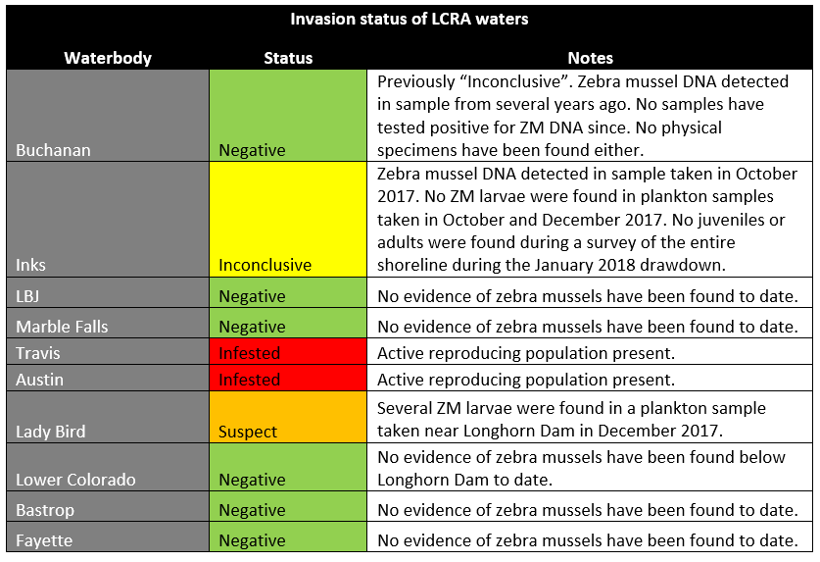
Figure 1. Zebra mussel invasion status of reservoirs in the lower Colorado River basin.
Lakes Fayette and Bastrop, which are nearby in the lower basin, are at lower risk of infestation by zebra mussels, Davis explained, due to their higher water temperatures. However, LCRA is still monitoring the lake for zebra mussels and making every effort to educate incoming boaters about the Clean Drain Dry protocol that must be followed prior to entering the lakes.

Davis said that the river below Austin may become infested with zebra mussels at low population levels downstream of Lady Bird Lake, but it is not expected that zebra mussels will be dispersed downstream significant distances because zebra mussels prefer reservoirs and lakes over flowing rivers and creeks.

Davis continued by highlighting that zebra mussels can have recreational, ecological and economic impacts. Scientists studying zebra mussels in Texas have documented a large “boom” in population when the mussels first invade, followed by a “bust” a few years later when their numbers decrease and they are not as much of an issue. But time will tell and populations will fluctuate throughout time. Davis said it is important to remember the Texas Parks and Wildlife Department’s Clean Drain Dry protocol to help prevent the spread of zebra mussels to other water bodies.

And now that zebra mussels are in these three middle basin lakes, they are there to stay. There is no feasible means of eradication and the focus needs to be on management, Davis stated.

There are a variety of management strategies that have been tried. These include manual removal, antifouling paints/alloys, chemical feed systems, desiccation, temperature control and flow control.

LCRA has taken many actions to address zebra mussels. A volunteer settlement sampler monitoring program has been in place for over 5 years in the Colorado River basin, an internal decontamination and spread prevention protocol has been developed for all LCRA watercraft, routine inspections of infrastructure are performed, and a thorough review of management techniques are among the actions taken. Davis stated that LCRA is a resource for anyone who has questions about zebra mussels. He provided his contact information so that anyone with questions could reach out: Stephen.davis@lcra.org.

The meeting concluded at 3:05 p.m.

Note: Throughout the meeting, several questions were asked related to zebra mussels, the City of Austin’s Water Forward process and specific break-down of CRP spending in the Colorado River basin. Benton followed-up with stakeholders via email after the meeting with additional resources to address those questions.

